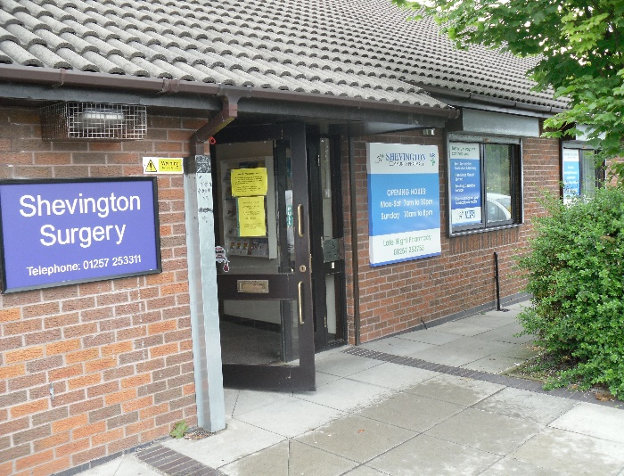

* No complaints.
* Reassuring call-back.
* Excellent organisation.
* Very impressed with the prompt reply.
* Always happy with Doctors and staff.
* Received no email or phone call.
* Faultless in all honesty.
* I would highly recommend this Doctors.
* Excellent service, speedy response.
* Efficient service.
* Matthew was very welcoming, thorough and helpful.
* Quick, efficient, helpful.
* Staff helpful and friendly.
* Doctor Humphreys is very good.
* Quick and excellent service.
* Great service and support as always.
* Fantastic speedy response by Dr Bose.

A

Thank you for your participation in this survey

*“Striving Towards Excellence”*

**Sample of Comments Received:**

**Shevington Surgery  
Friends & Family Results   
June 2023**