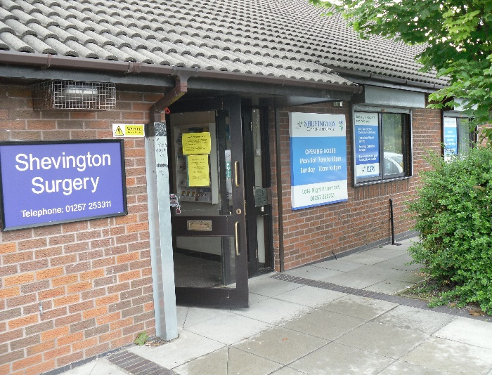

* First class service.
* Very efficient and quick.
* Immediate response from the surgery.
* Very polite staff.
* Thank you Carolyn for prompt response.
* Feel very lucky to have such a great GP practice.
* Excellent service.
* Extremely efficient.
* Lots of care and consideration from Dr Bose.
* Prompt, warm, friendly attention.
* Dr Carver made me feel at ease, very thorough and professional.
* Seen on time, polite, helpful & efficient staff.
* Great service, professional.
* Prompt, warm, friendly attention.
* No wait. Quick concise diagnosis.
* Good response from the service & GP.

A

Thank you for your participation in this survey

*“Striving Towards Excellence”*

**Sample of Comments Received:**

**Shevington Surgery  
Friends & Family Results   
July 2023**