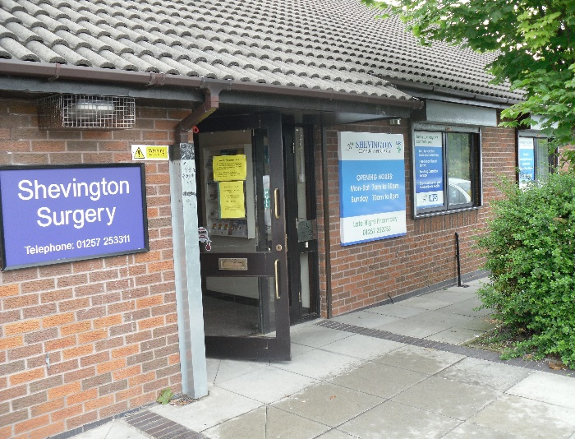

* Very polite staff.
* Excellent prompt service.
* Very good practice with kind, helpful staff.
* Submitted request at 07:30, saw Nurse Practitioner at 08:45 – Brilliant!
* Great staff and great service as always.
* Dr Carver very understanding and easy to speak to. Excellent service.
* Still impossible to find link on the internet.
* Very friendly and helpful.
* The service they provide is very good.
* The Nurse I saw was fantastic and really put me at ease.
* Feel cared for and treated well.
* Saw Doctor on time, issue dealt with professionally and quickly.
* The Advanced Practitioners & GPs have always been amazing, plus Karen on reception

A

Thank you for your participation in this survey

*“Striving Towards Excellence”*

**Sample of Comments Received:**

**Shevington Surgery  
Friends & Family Results   
August 2023**